ISE Profiling Steps Guide
This guide provides a comprehensive overview of the steps required to set up and configure profiling in Cisco Identity Services Engine (ISE). Profiling allows ISE to identify and classify endpoints on the network, enabling more granular access control and enhanced security.
We normally get request to add MAC address to the profiling policies so end points can connect to the right vlan. (example request: VISTA - Create MAC profile for VLAN9.We had to replace the printer and need to register the MAC for VLAN9) Printer MAC: A8:B1:3B:67:86:04
Configuring Profiling Policies
1. Check current policies for VLAN 9 access. Go to work centers policy set.
If the policy is not in place for a specific vlan, this means that you need to create the policy as well.
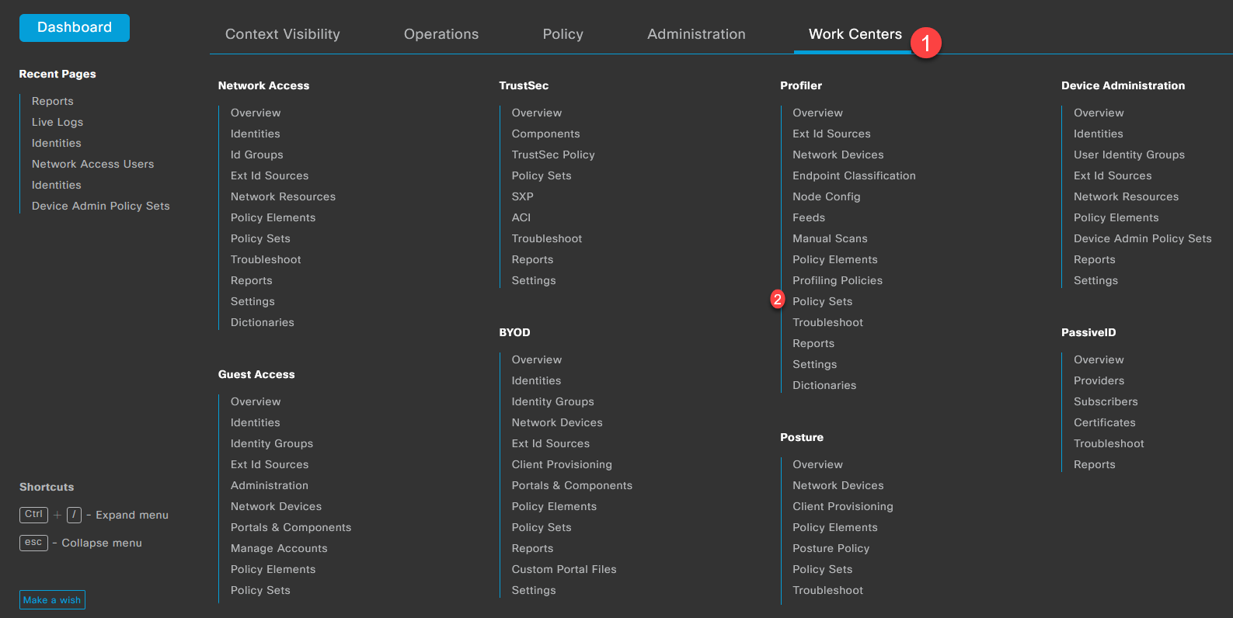
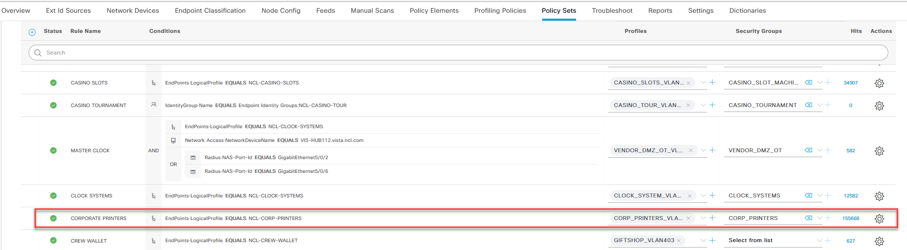
If the policy is there, check the profile that is being used for the access on that VLAN in this case.
CORP-PRINTERS
The next step is to create a condition that can be attached to that profile. Go to Policy Elements and add the new condition to match the Mac address provided on the request.
Note: Check the conditions in place before creating a new one; there are some general conditions that match vendor OUI.
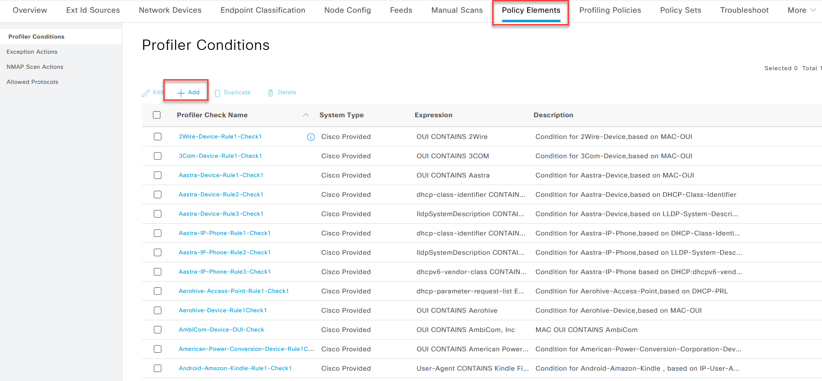
All condition names should start with NCL-NAME and, in the description, the VLAN to which it belongs.
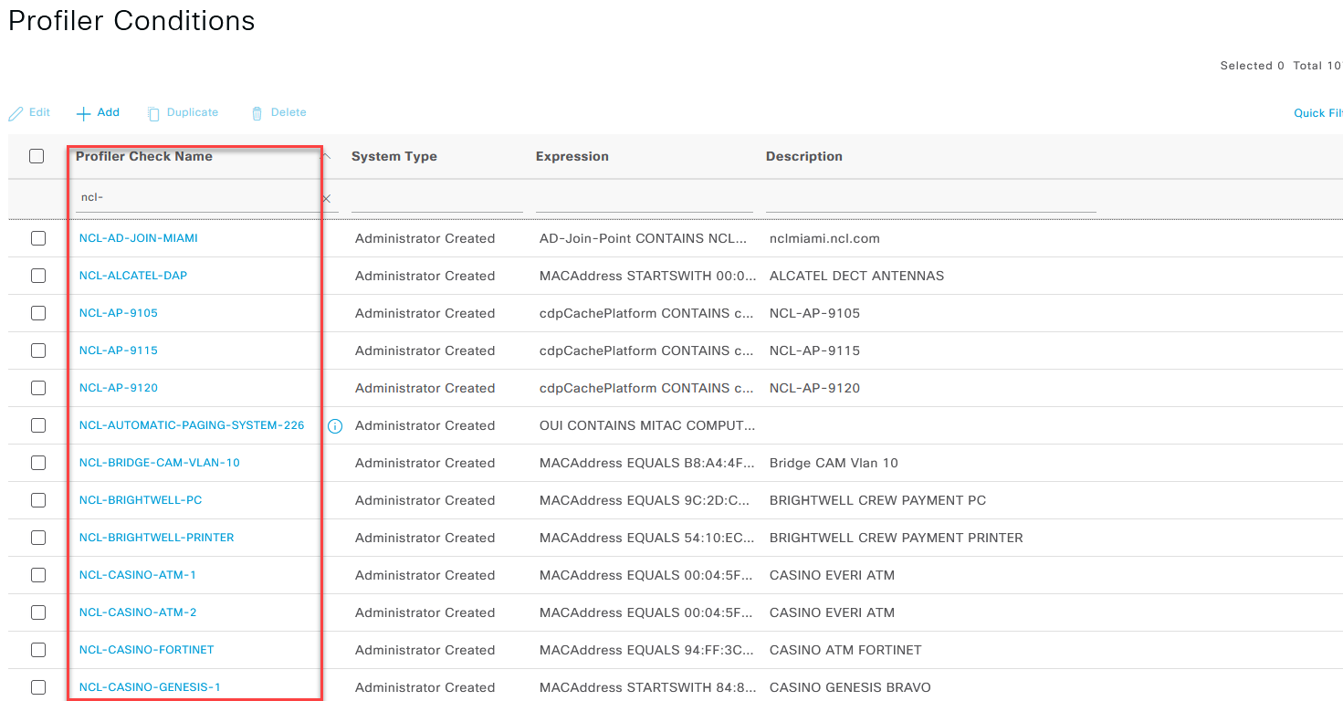
Proceed and create the new condition for the Printer going on VLAN 9
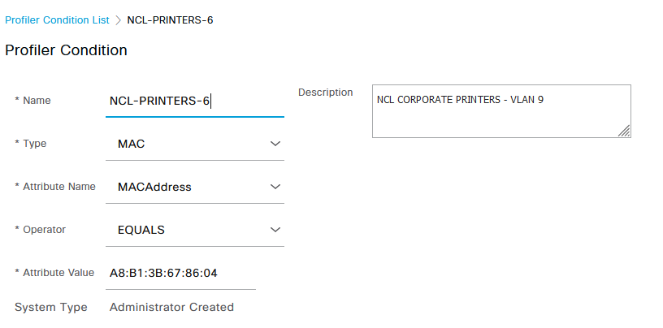
Now go to the profiling policies and search the policy that match the access for the vlan that you are looking for.
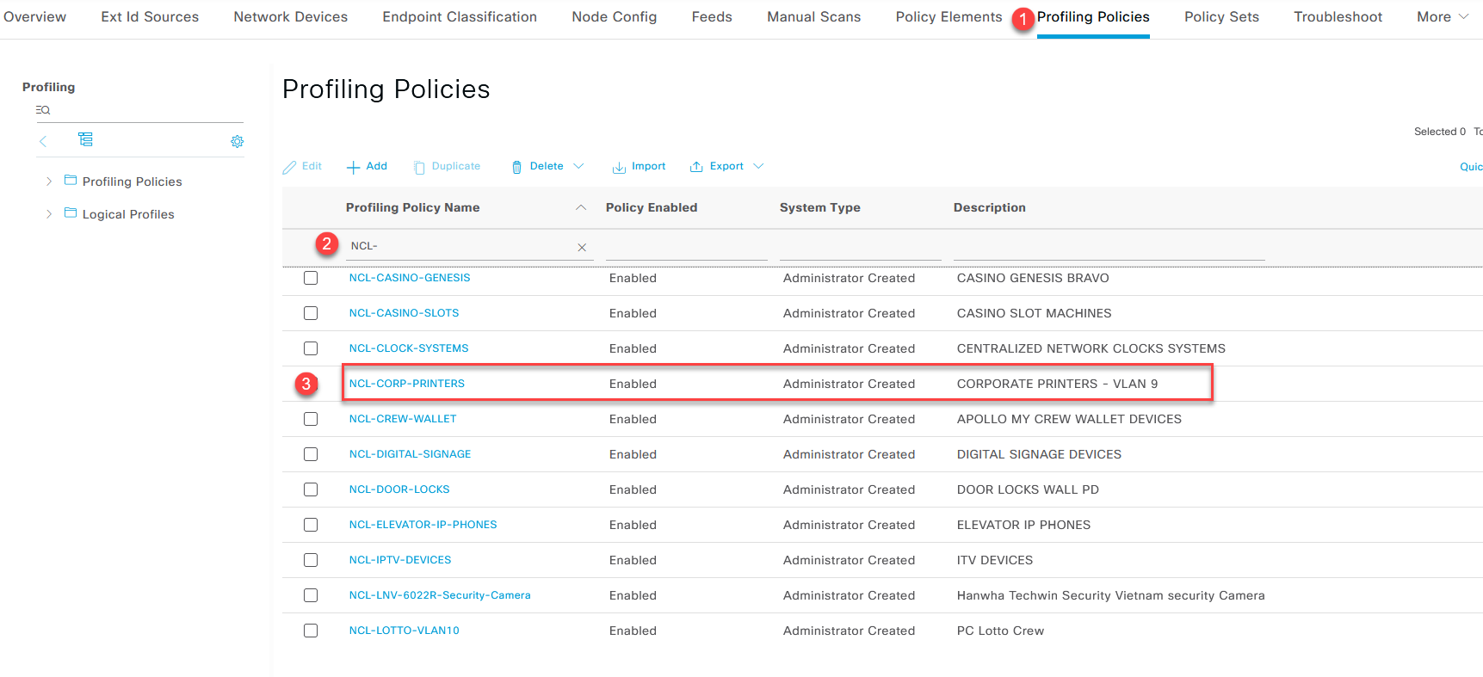
Now insert a new rule below the current rules with the condition that you created previously. In this case NCL-PRINTERS-6.
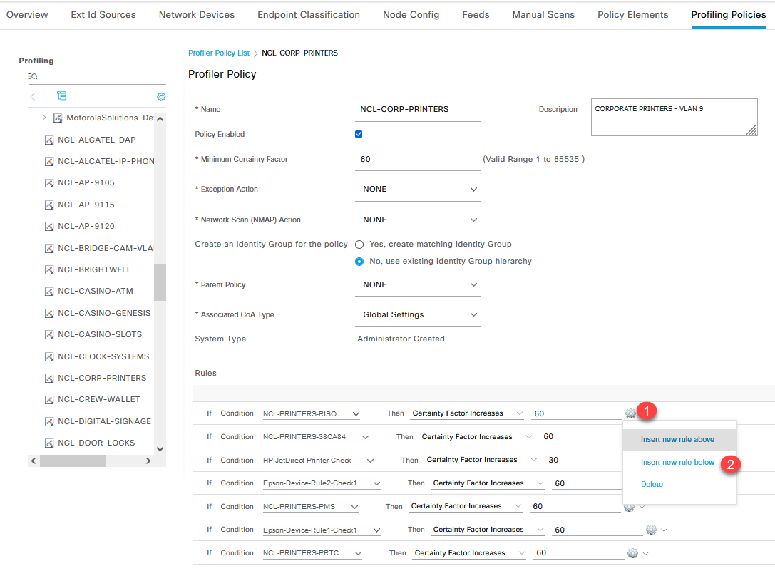
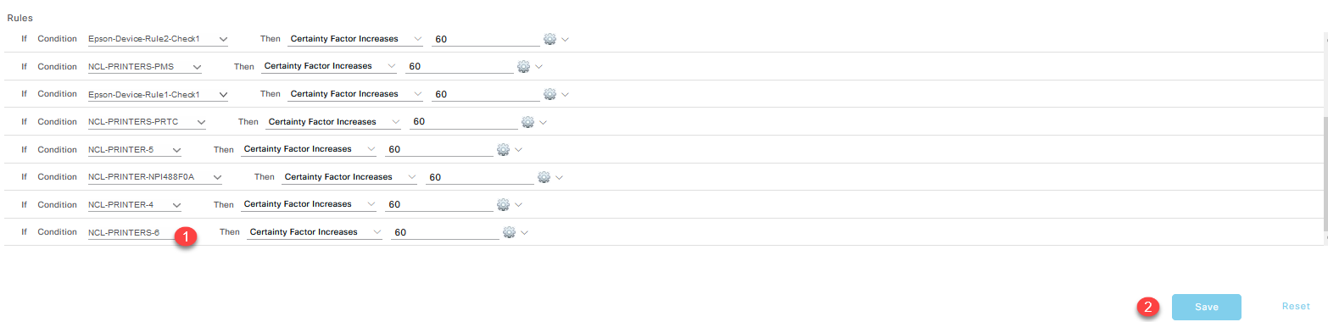
Save the config, and the new Mac address should be able to authenticate.
Note: Mac address is case sensitive, so always add the MAC address in Uppercase.
If you need to create access for a new VLAN, you need to create a new authorization policy and set a new authorization profile.
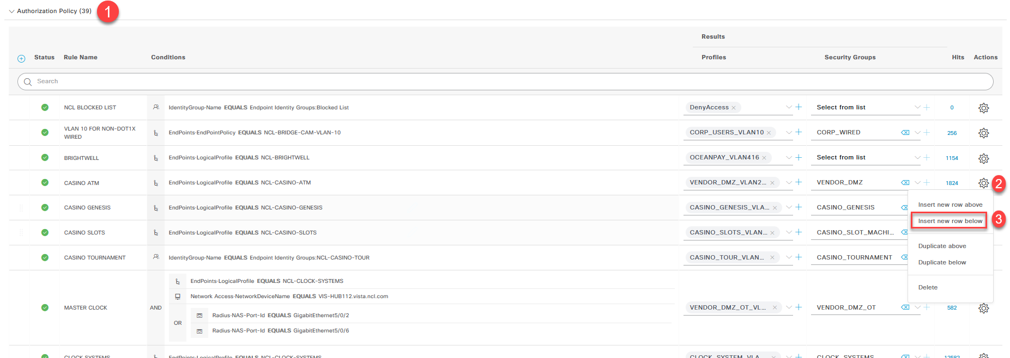
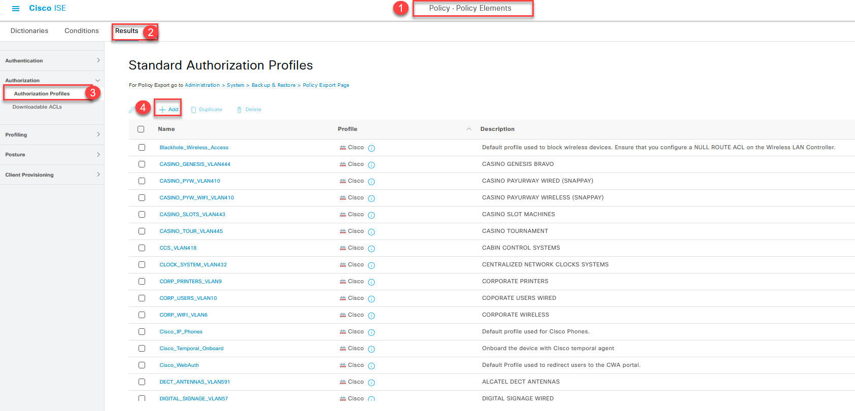
If you have any question reach out to shipboard team.

